Jerome Anaeki

**Homework 1**

Screenshot

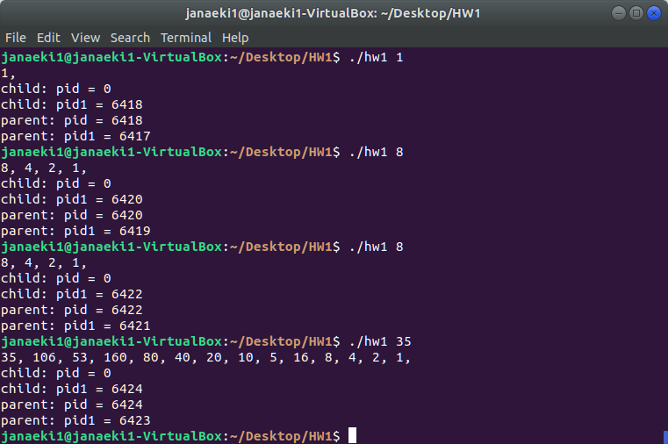

Source Code

#include <stdio.h>

#include <unistd.h>

#include <sys/types.h>

/*

* hw1.c

*

* This program displays the process IDs of both the parent and child processes.

* It also explores the Collatz conjecture:

* n = n/2, if n is even

* OR

* n = 3 * n + 1, if n is odd

* This proves all positive integers will eventually reach 1

*

*/

int main(int argc, char *argv[])

{

int n;

if (argc == 1) {

fprintf(stderr,"Usage: ./hw1 <starting value>\n");

return -1;

}

n = atoi(argv[1]); // n is the input starting value

pid_t pid, pid1;

/* fork a child process */

pid = fork();

if (pid < 0) { /* error occurred */

fprintf(stderr, "Fork Failed");

return 1;

}

else if (pid == 0) { /* child process */

printf("%d, ", n);

while(n > 1){

if(n%2 == 0){

n /= 2;

}

else{

n=3 * n + 1;

}

printf("%d, ", n);

}

printf("\n");

pid1 = getpid();

printf("child: pid = %d\n",pid); /* A */

printf("child: pid1 = %d\n",pid1); /* B */

}

else { /* parent process */

wait(NULL);

pid1 = getpid();

printf("parent: pid = %d\n",pid); /* C */

printf("parent: pid1 = %d\n",pid1); /* D */

}

return 0;

}